Site URL: http://fivestarlogitech.com/adinfosys/ - Frontend View
Admin Panel Details:
- URL: http://fivestarlogitech.com/adinfosys/admin-login/
- Username: admin@gmail.com
- Password: 123456

Documentation to use the CMS

- After successful login you will see a screen like the below image:
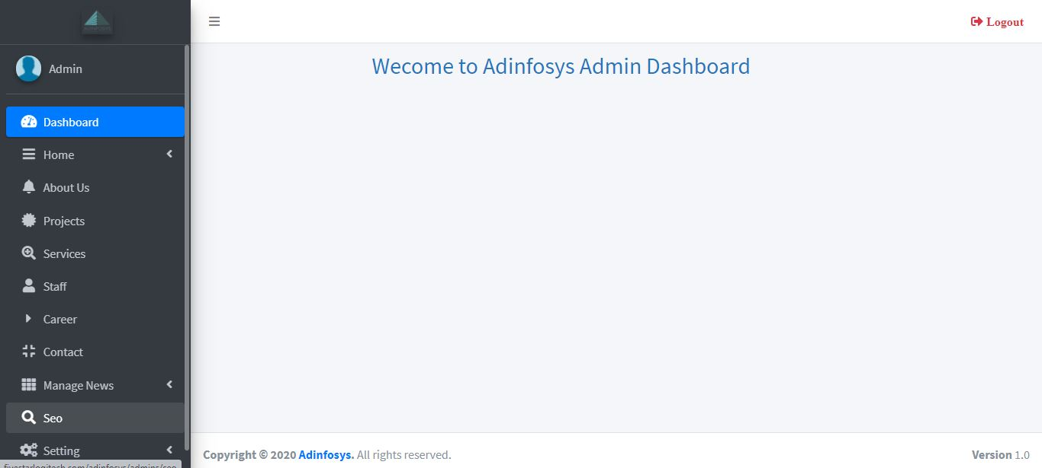

In-order to manage the CMS, there are various attributes we need to follow. The attributes are the following.
- Add/Edit/delete ( To add, modify or delete the content)
- Submit button ( To publish the content)
- Action button ( To activate the published content)
- Home Banner Management: Click on manage banner” Here you can the list of banners with images and their alt text. To add a banner in the home page, enter the banner name, choose the banner size (1500 x 750 pxl), write a description and click on submit button. Then click on action button which shows cross mark. Click on it and it will show right mark which means the content is published.

- Manage our partner: Here you can add the client/partner logo and the changes will be reflected in client & partner page. Follow same procedure like banner management.

- About us page management: Click on about us in Admin panel. Put text in the heading box,
Choose the image size (450 * 300), Put the text in the description about your organization. The text and image will appear in both Home page and about us page.

- Then the next section is Project management page: Here you can Add/Edit/delete the project information. For demo purpose we have added some project information. However In-order to add new project, click on Projects: You can there is an option to add project. Put the project tile in the text box area. Then put the text on project details in the description box. Then click on submit. Don’t forget to click on action area.

- Then Service section: For demo purpose we have uploaded some contents. However you may delete the content and start from scratch. Click on Services. In the right side, you can see add services. Add the services name, Choose image size (400x300 pxl) and put the service info. In the description. Clicks on submit and then click on action button to activate the published content. This service info will be displayed in both Home page sections as well as in the services section.

- Staff Management page: Click on staff, and then in the right side you can see the heading box as well as the description box. Put the text in the particular section. Click on submit button and click in action button to activate the published content.

- Career page: Click on career section. You can add the text through same procedure. In the career page, you can see a form in right side. If any user will provide necessary information through the form, then the user information and attached doc file will be sent to your email ID.

- Contact section: Here you can edit the contact information. The contact information will be updated in both contact us page as well as in the Footer section contact us information area.

- Manage News: Click on Add news (under manage news section). Here you can put the news title in the heading box. Then choose an image((800 * 550) size image pxl), then put the news description. Click on submit button and then click on action area to activate the published content.

You can see news list under manage news section. You can views all the published news here. If you want to modify the news details, you can click on Edit button.
- SEO Management: Click on SEO. Now you can see all the pages with an action button. If you click on action button, then it will show you the section to change the Meta attributes.
Meta title is a HTML code in the header of a web page. The meta title should be relevant to the domain, service or products.

Meta description is an HTML element that describes and summarizes the contents of your page for the benefit of users and search engines.

After fixing these meta attributes, when you the start the SEO work, these meta attributes will send information to Google
- “Common Settings”, on click there are links for different action. Let’s start one by one.
  - Account settings: In account settings, you can change name, login email, phone no and profile picture. Also you can change the password through change password tab.
  - Site Settings: Here you can manage the logo.
  - Site Email: This email is used to send the site’s form details like contact us form, career form etc.
  - Social Management: Update the social site link through this functionality.

